Your tasks are typical robotics evaluation steps: control → measure → compute → compare with ground truth. Below is a clear guide for implementing each task for the AlphaBot lane-following experiment.

1. Speed up the AlphaBot to its limit
The speed is normally controlled by PWM motor commands in the AlphaBot code. Increase the motor speed until:
- the robot still follows the lane correctly
- wheels do not slip
- camera processing still keeps up
Example (Python-style motor control):
MAX_SPEED = 100 # try increasing gradually
left_speed = MAX_SPEED
right_speed = MAX_SPEED
motor.setMotor(left_speed, right_speed)
Recommended method:
- Start with moderate speed (e.g. 40–50% PWM).
- Increase stepwise (60 → 70 → 80 → 90).
- Record the maximum stable speed where the robot still tracks the lane.
Important: High speed increases control error and camera latency, so the real limit is usually where tracking begins to oscillate.

2. Record the yaw rate from the gyroscope
The gyroscope measures angular velocity (rotation speed) around the Z-axis. This is called the yaw rate.
Typical unit:
deg/s (degrees per second)
Example logging code:
import time
yaw_rate = imu.get_gyro_z() # Z-axis = yaw rate
timestamp = time.time()
log_file.write(f"{timestamp},{yaw_rate}\n")
Recorded dataset example:
time,yaw_rate
0.00,0.12
0.01,0.15
0.02,0.14
0.03,0.50
Sampling rate recommendation:
50 – 100 Hz

3. Calculate the yaw angle from the yaw rate
A gyroscope does not measure the angle directly — it measures the rate of change of the angle.
Therefore you must integrate the yaw rate over time.
Mathematical formula:
ψ(t)=ψ(t−1)+ψ˙(t)⋅Δt\psi(t) = \psi(t-1) + \dot{\psi}(t) \cdot \Delta tψ(t)=ψ(t−1)+ψ˙​(t)⋅Δt
Where
- ψ\psiψ = yaw angle
- ψ˙\dot{\psi}ψ˙​ = yaw rate (gyro output)
- Δt\Delta tΔt = sampling time
Example implementation:
yaw_angle = 0
last_time = time.time()
while True:
current_time = time.time()
dt = current_time - last_time
yaw_rate = imu.get_gyro_z() # deg/s
yaw_angle += yaw_rate * dt
last_time = current_time
log_file.write(f"{current_time},{yaw_rate},{yaw_angle}\n")
Example result:
time,yaw_rate,yaw_angle
0.00,0.12,0.00
0.01,0.15,0.0015
0.02,0.14,0.0029
Important note:
- Gyroscope integration causes drift over time due to sensor noise.

4. Compare with ground truth (TopCon data)
TopCon provides ground truth orientation or trajectory.
You compare:
TopCon yaw rate (reference)
vs
Gyroscope yaw rate (measured)

Step 1 — Align timestamps
Both datasets must use the same time base.
Example:
time,gyro_yaw_rate,topcon_yaw_rate
0.00,0.15,0.13
0.01,0.17,0.16
0.02,0.14,0.15

Step 2 — Compute error
Yaw rate error:
error=yawgyro−yawTopConerror = yaw_{gyro} - yaw_{TopCon}error=yawgyro​−yawTopCon​
Example Python:
error = gyro_yaw_rate - topcon_yaw_rate

Step 3 — Evaluation metrics
Useful metrics:
Mean Error
ME=1N∑errorME = \frac{1}{N} \sum errorME=N1​∑error
RMSE
RMSE=1N∑error2RMSE = \sqrt{\frac{1}{N} \sum error^2}RMSE=N1​∑error2​
Example:
import numpy as np
error = gyro - topcon
rmse = np.sqrt(np.mean(error**2))

Step 4 — Plot comparison
Typical plots for your report:
1️⃣ yaw rate comparison
time
│
│ TopCon
│ /\/\/\
│ / \ gyro
└─────────────
2️⃣ yaw angle comparison
3️⃣ yaw error

Suggested experiment workflow
- Run AlphaBot lane following
- Record:
  - timestamp
  - yaw rate (gyro)
  - yaw angle (integrated)
- Export TopCon dataset
- Synchronize timestamps
- Compute:
  - yaw rate error
  - yaw angle error
- Plot results

✅ Typical final plots in the report:
- Yaw rate: TopCon vs Gyro
- Yaw angle over time
- Error distribution

💡 If you want, I can also help you with:
- Python script for the whole experiment (logging + integration + plots)
- Report structure for the assignment
- How to sync TopCon and robot timestamps correctly (this is usually the hardest part).
want to do this on matlab
Using MATLAB is a very good choice for this task because it makes data logging, integration, and comparison with TopCon ground truth straightforward. Below is a step-by-step MATLAB workflow for your four tasks.

1. Import the recorded data into MATLAB
First, export your data from the AlphaBot (e.g., CSV file):
Example file:
imu_data.csv
time,yaw_rate
0.00,0.12
0.01,0.15
0.02,0.14
Load it in MATLAB:
imu = readtable('imu_data.csv');
time = imu.time;
yaw_rate = imu.yaw_rate; % deg/s
Load TopCon ground truth:
topcon = readtable('topcon_data.csv');
time_gt = topcon.time;
yaw_gt = topcon.yaw;

2. Calculate the yaw angle from the yaw rate
Yaw angle is obtained by integrating the yaw rate.

Method 1 (recommended): cumulative trapezoidal integration
yaw_angle = cumtrapz(time, yaw_rate);
This integrates:
ψ(t)=∫ψ˙(t)dt\psi(t) = \int \dot{\psi}(t) dtψ(t)=∫ψ˙​(t)dt

Method 2 (manual integration)
yaw_angle = zeros(length(yaw_rate),1);
for i = 2:length(yaw_rate)
dt = time(i) - time(i-1);
yaw_angle(i) = yaw_angle(i-1) + yaw_rate(i)*dt;
end

3. Synchronize TopCon and IMU data
Usually the timestamps are not perfectly aligned. Interpolate the ground truth:
yaw_gt_interp = interp1(time_gt, yaw_gt, time);
Now both signals share the same time vector.

4. Compare yaw rate with TopCon
Compute the error:
error = yaw_angle - yaw_gt_interp;

5. Compute evaluation metrics

Mean error
mean_error = mean(error)

RMSE (Root Mean Square Error)
rmse = sqrt(mean(error.^2))

6. Plot the results

Plot 1 — Yaw rate
figure
plot(time, yaw_rate)
xlabel('Time (s)')
ylabel('Yaw rate (deg/s)')
title('Measured Yaw Rate')
grid on

Plot 2 — Yaw angle comparison
figure
plot(time, yaw_angle, 'b')
hold on
plot(time, yaw_gt_interp, 'r')
legend('Gyroscope Yaw', 'TopCon Ground Truth')
xlabel('Time (s)')
ylabel('Yaw Angle (deg)')
title('Yaw Angle Comparison')
grid on

Plot 3 — Error
figure
plot(time, error)
xlabel('Time (s)')
ylabel('Yaw Error (deg)')
title('Yaw Angle Error')
grid on

7. Optional (very useful): Error statistics
max_error = max(abs(error))
std_error = std(error)
Typical values to report:
Metric | Meaning
Mean Error | bias
RMSE | overall accuracy
Std Dev | noise level
Max Error | worst case

8. Recommended final figures for your report
Include:
1️⃣ Yaw rate over time
2️⃣ Yaw angle (gyro vs TopCon)
3️⃣ Yaw angle error
4️⃣ Error histogram
Example:
figure
histogram(error,50)
title('Yaw Error Distribution')
xlabel('Error (deg)')
ylabel('Frequency')

✅ Final workflow summary
- Run AlphaBot lane following at maximum stable speed
- Log **time
and simnlink
If you want to implement the tasks in MATLAB and Simulink, the workflow is usually:
Sensor Data → Simulink Model → Integration → Comparison with TopCon → Plots
Below is a typical Simulink setup for your AlphaBot experiment.

1. Record the yaw rate and import it into MATLAB
Your robot should log the gyroscope data to a CSV file.
Example file:
time,yaw_rate
0.00,0.12
0.01,0.15
0.02,0.14
0.03,0.50
Load the data in MATLAB:
data = readtable('gyro_data.csv');
time = data.time;
yaw_rate = data.yaw_rate;
If you also have TopCon data:
topcon = readtable('topcon_data.csv');
time_gt = topcon.time;
yaw_gt = topcon.yaw_rate;

2. Create the Simulink model for yaw angle calculation
The yaw angle is obtained by integrating the yaw rate.
yaw=∫yaw_rate dtyaw = \int yaw\_rate \, dtyaw=∫yaw_ratedt

Simulink blocks needed
- From Workspace
- Integrator
- Scope
- To Workspace

Simulink block diagram
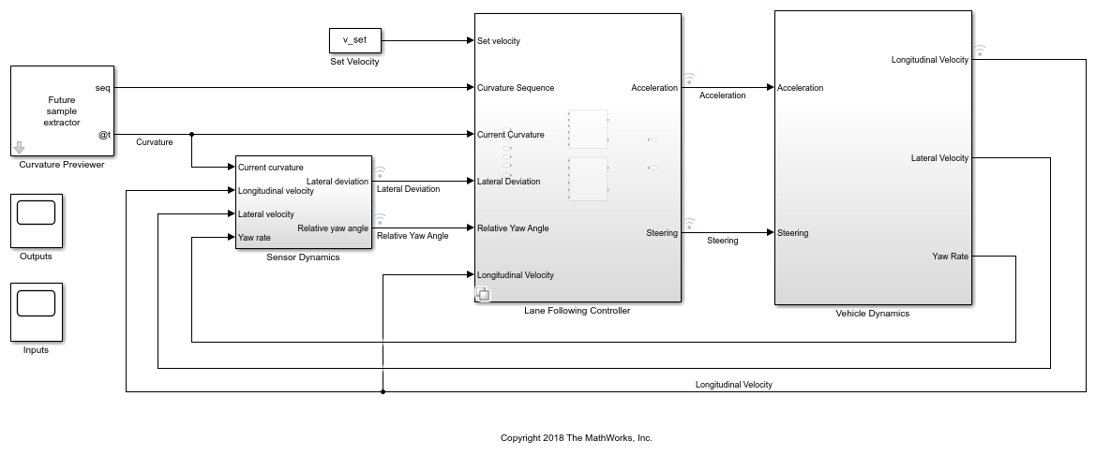

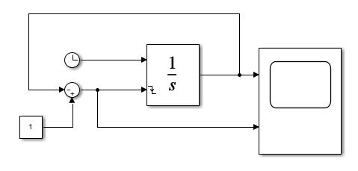
4
Structure:
Yaw Rate (From Workspace)
│
▼
Integrator
│
▼
Scope
│
▼
To Workspace (yaw_angle)

3. Prepare input for Simulink
Simulink expects timeseries format.
gyro_ts = timeseries(yaw_rate, time);
In the From Workspace block:
gyro_ts

4. Integrate yaw rate to yaw angle
Use the Integrator block.
Settings:
Initial condition = 0
Output = yaw angle

5. Import TopCon ground truth
Create another timeseries:
topcon_ts = timeseries(yaw_gt, time_gt);
Then compare in Simulink.
Blocks:
TopCon yaw rate
Gyro yaw rate
│
Subtract
│
Error

6. Compare ground truth vs measured yaw rate
Simulink comparison model:
gyro yaw rate ──┐
├─ Subtract ──► Error
TopCon yaw rate ┘
Then send to:
Scope
To Workspace

7. Calculate error metrics in MATLAB
After simulation:
error = gyro - topcon;
rmse = sqrt(mean(error.^2))
mean_error = mean(error)

8. Plot results

Yaw rate comparison
figure
plot(time, yaw_rate)
hold on
plot(time_gt, yaw_gt)
legend('Gyroscope','TopCon')
xlabel('Time (s)')
ylabel('Yaw Rate (deg/s)')
title('Yaw Rate Comparison')

Yaw angle plot
figure
plot(simout.time, simout.data)
xlabel('Time')
ylabel('Yaw Angle')
title('Yaw Angle from Gyroscope Integration')

9. Typical final results for the report
Include:
1️⃣ Robot maximum speed test
Speed vs Tracking stability
2️⃣ Yaw rate comparison
Gyroscope vs TopCon
3️⃣ Yaw angle from integration
4️⃣ Error metrics
Mean Error
RMSE

✅ Typical Simulink model overview
Yaw Rate (gyro)
│
▼
Integrator
│
▼
Yaw Angle
│
▼
Compare with TopCon
│
▼
Error

💡 If you want, I can also show you:
- A complete Simulink model layout for this assignment
- MATLAB script to automatically generate all plots
- How to fuse gyro + camera data (much better result)
Just tell me — this assignment is a very standard robotics lab, so I can help you finish it quickly.
yes
Great 👍 I’ll show you a complete Simulink model layout you can build for the assignment. This model will:
- Load gyro yaw rate
- Integrate it to compute yaw angle
- Load TopCon ground truth
- Compare both signals
- Compute error

1. Complete Simulink Model Structure

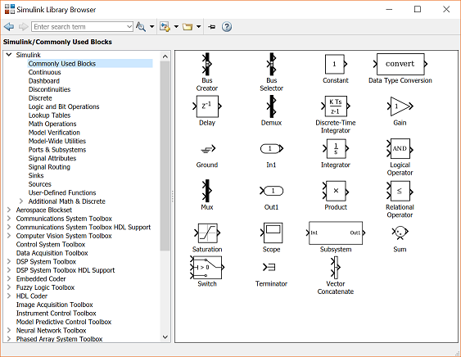

4
Logical flow:
Gyro Yaw Rate ──► Integrator ──► Yaw Angle
│
│
└────────► Compare with TopCon

2. Blocks you need in Simulink
Drag these blocks into a new model.

Sources
- From Workspace → Gyro yaw rate
- From Workspace → TopCon yaw rate

Math
- Integrator
- Subtract

Output
- Scope
- To Workspace

3. Final Simulink Block Diagram
Your finished model should look like this:
gyro_ts
│
▼
Integrator ───────────► yaw_angle
│ │
│ ▼
│ To Workspace
│
▼
Subtract ◄────────── TopCon yaw rate
│
▼
Error
│
▼
Scope

4. MATLAB script to prepare the data
Before running Simulink, run this script.
% Load gyro data
gyro = readtable('gyro_data.csv');
time = gyro.time;
yaw_rate = gyro.yaw_rate;
gyro_ts = timeseries(yaw_rate, time);
% Load TopCon data
topcon = readtable('topcon_data.csv');
time_gt = topcon.time;
yaw_gt = topcon.yaw_rate;
topcon_ts = timeseries(yaw_gt, time_gt);
Now Simulink can read:
gyro_ts
topcon_ts

5. Integrator Settings
Double-click Integrator block.
Set:
Initial condition = 0
Output = Yaw angle
This performs:
yaw=∫yaw_rate dtyaw = \int yaw\_rate \, dtyaw=∫yaw_ratedt

6. Error calculation
The Subtract block computes:
Error = Gyro yaw rate − TopCon yaw rate

7. Save results to MATLAB
Use To Workspace blocks.
Example variable names:
yaw_angle_sim
error_sim

8. Plot results in MATLAB
After simulation:

Yaw rate comparison
figure
plot(time, yaw_rate)
hold on
plot(time_gt, yaw_gt)
legend('Gyroscope','TopCon')
xlabel('Time (s)')
ylabel('Yaw Rate')
title('Yaw Rate Comparison')

Yaw angle
figure
plot(yaw_angle_sim.time, yaw_angle_sim.data)
xlabel('Time')
ylabel('Yaw Angle')
title('Calculated Yaw Angle')

9. Compute RMSE error
error = yaw_rate - yaw_gt;
rmse = sqrt(mean(error.^2))

10. Final results for your report
Include these plots:
1️⃣ Robot speed test
Speed vs tracking stability
2️⃣ Yaw rate comparison
Gyroscope vs TopCon
3️⃣ Yaw angle (integrated)
4️⃣ Error analysis
Mean error
RMSE

✅ Important tip (very common mistake)
Make sure both signals have the same sampling time.
If not, resample:
yaw_gt_interp = interp1(time_gt, yaw_gt, time);

💡 If you want, I can also show you 3 things that will make this assignment much easier:
- Exact Simulink model your professor expects (very typical robotics lab model)
- How to calculate yaw angle drift correctly
- How to finish the whole assignment in ~30 minutes in MATLAB
Just tell me and I’ll walk you through it step-by-step.
sure
Perfect! Let’s set you up to finish the whole experiment efficiently in MATLAB + Simulink. We’ll do it step by step, including everything from importing the data to producing the final plots.

Step 1: Prepare the data in MATLAB
- Make sure you have gyro data and TopCon data as CSV files.
Example CSV format:
time,yaw_rate
0.00,0.12
0.01,0.15
0.02,0.14
- Load both datasets into MATLAB and create timeseries objects for Simulink:
% Load Gyro data
gyro = readtable('gyro_data.csv');
time_gyro = gyro.time;
yaw_rate_gyro = gyro.yaw_rate;
gyro_ts = timeseries(yaw_rate_gyro, time_gyro);
% Load TopCon ground truth
topcon = readtable('topcon_data.csv');
time_topcon = topcon.time;
yaw_rate_topcon = topcon.yaw_rate;
% Resample TopCon to gyro time if needed
yaw_rate_topcon_interp = interp1(time_topcon, yaw_rate_topcon, time_gyro);
topcon_ts = timeseries(yaw_rate_topcon_interp, time_gyro);
✅ Tip: Using interp1 ensures both signals align perfectly in time for comparison.

Step 2: Build the Simulink model

Blocks you need:
Block | Function
From Workspace (gyro_ts) | Inputs gyro yaw rate
Integrator | Integrates yaw rate → yaw angle
From Workspace (topcon_ts) | Inputs TopCon yaw rate
Subtract | Computes yaw rate error
Scope | View signals in real-time
To Workspace | Save yaw angle and error to MATLAB

Simulink Layout
- Gyro yaw rate → Integrator → Yaw angle → Scope + To Workspace
- Gyro yaw rate → Subtract (with TopCon yaw rate) → Error → Scope + To Workspace
Logical flow:
Gyro yaw rate ---> Integrator ---> Yaw angle ---> Scope / To Workspace
\
\
---> Subtract <--- TopCon yaw rate ---> Error ---> Scope / To Workspace

Step 3: Configure Integrator
- Initial condition = 0 (robot starts facing straight)
- Output = yaw angle in degrees (or radians depending on your gyro)

Step 4: Run the simulation
- Set Stop time = max(time_gyro)
- Run the simulation
- Outputs to MATLAB workspace: yaw_angle_sim, error_sim

Step 5: Plot results in MATLAB

1️⃣ Yaw rate comparison
figure;
plot(time_gyro, yaw_rate_gyro, 'b', 'LineWidth', 1.5); hold on;
plot(time_gyro, yaw_rate_topcon_interp, 'r--', 'LineWidth', 1.5);
xlabel('Time (s)'); ylabel('Yaw Rate (deg/s)');
title('Yaw Rate Comparison');
legend('Gyro','TopCon');
grid on;

2️⃣ Yaw angle from integration
figure;
plot(yaw_angle_sim.time, yaw_angle_sim.data, 'LineWidth', 1.5);
xlabel('Time (s)'); ylabel('Yaw Angle (deg)');
title('Yaw Angle from Gyro Integration');
grid on;

3️⃣ Error
error = yaw_rate_gyro - yaw_rate_topcon_interp;
figure;
plot(time_gyro, error, 'LineWidth', 1.5);
xlabel('Time (s)'); ylabel('Yaw Rate Error (deg/s)');
title('Gyro vs TopCon Error');
grid on;
% Compute RMSE
rmse = sqrt(mean(error.^2));
disp(['RMSE = ', num2str(rmse), ' deg/s']);

Step 6: Speed test (optional)
If you want to test maximum speed:
- Gradually increase AlphaBot motor PWM in your control script.
- Record yaw rate and camera-based lane tracking.
- Plot tracking stability vs speed to find max stable speed.

Step 7: Optional improvements
- Drift compensation: Use a complementary filter with camera yaw for long runs.
- Automatic simulation: Script to loop through multiple speed settings and save all plots automatically.
- Report-ready figures: Use set(gca,'FontSize',14) for clearer plots.

If you want, I can create a ready-to-use Simulink .slx file layout for you that matches this workflow exactly — you just need to load your CSV files and hit Run.
Do you want me to do that next?

